Cross Bayou Elementary
School Improvement Plan Summary for the 22/23 school year
SIP Goals
- Proficiency in ELA will increase 10% from 39% to 49%
- Proficiency in Math will increase 10% from 48% to 58%
- Proficiency in Science will increase 10% from 48% to 58%
- Black Student proficiency in ELA will increase from 33% to 41% and in Math from 13% to 41%
- Students with Disabilities proficiency in ELA and Math will increase from 15% to 41%
Standards Based instruction to increase proficiency in ELA, Math and Science
- Lessons aligned to the standards at each grade level
- Understanding BEST Standards and resources that support these standards
- Data driven instruction to meet specific needs of students
- Goal review and goal setting with students each grading period
- PCS Connects devices utilized at school and at home for classroom and at home extended learning
- Research-based interventions that support student acquisition of skills are aligned with student need
- Bi-Monthly PLC’s focus on data analysis, instruction and research-based strategies
Culture and Climate
- Class Dojo being used school-wide
- Monthly Assemblies to highlight students and staff accomplishments
- Leadership opportunities for students (PMAC, Happy Hands signing group, SAVE Club and Bayou Crew)
- Book study and Professional Development opportunities for staff on Restorative Practices and Equity
- Monthly School-wide Incentive
- School-Wide Expectations used in classrooms and common areas of campus
Positive Culture and Environment related to Attendance
- Monitoring Attendance through Child Study Team
- Personal phone calls to families to provide assistance
- Weekly incentive drawing
- Classroom competition each week for the Bobcat Belt
- Parent Incentives for on-time arrival
- Students are not released the last 30 minutes of the school day

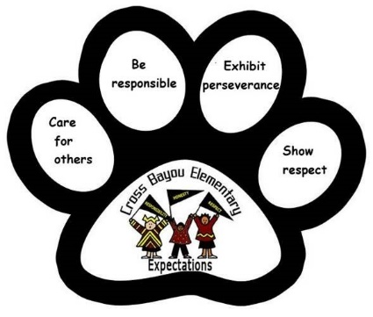
Cross Bayou Elementary will provide a caring and success-oriented learning environment that enables each child to become a respectful, responsible and motivated lifetime learner through a collaborative effort among students, staff and community.

